MICROSCOPES

The following diagram of the common microscope and its labelled parts need to be remembered.

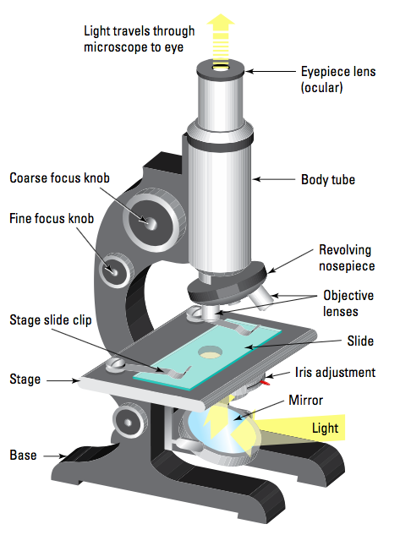

Important Rules For Using Microscopes

• Make sure the mirror reflects light up through the stage.
• Focus on low power first.
• Look from the side to adjust the objective lens just above the slide.
• Use the coarse focus to wind the eye piece upwards under low power.
• Look from the side when switching to higher power lenses to avoid hitting the slide.
• Use the fine focus when looking under high power.

Activity

• Do Activity 3.1 p. 42 Science Quest 8.

